DRAFT: Public Engagement Plan

Maine State Service Strategy 2027–2030
Prepared by: Maria Millard | For: Volunteer Maine
Presented to the Maine Commission for Community Service (MCCS): April 17, 2026 | Status: Draft

1. Purpose and Framing
Building Maine’s 2027–2030 State Service Strategy starts with engaging Maine people. This engagement plan outlines how Volunteer Maine will connect with people across the state — what we want to learn, and how we’ll engage — in a way that deepens relationships and elevates the role of Commissioners.

This process is more than a planning exercise.
We have a new opportunity to define what Volunteer Maine is and does for Maine's volunteer sector and the public. This process will ensure that every participant will leave with a clearer picture of Volunteer Maine's role, and a stronger sense of connection to the organization.

Our 19 Commissioners are this strategy's most important asset. Each one carries relationships, gravitas, geographic reach, and a commitment to service. This plan is designed to position Commissioners as champions of Maine's volunteer sector. Section 5 describes Commissioner roles.

2. What We Want to Learn
The following topics are drawn from internal look-back sessions, task force discussions, and the unresolved questions that have surfaced across prior planning cycles.
- Volunteer Maine’s Identity & Visibility
- Partnerships & Ecosystem
- Rural & Community Reach
- Youth & the Volunteer Pipeline
- Program Focus & Effectiveness

The Facilitator Guide, located in Appendix A, includes specific questions for each topic listed above.

3. Engagement Approach
This plan aims to engage people across Maine's regions, sectors, communities, and lived experiences. We will meet people where they are — in their communities, in formats that work for them, and with genuine curiosity about what they know and what they need. We will commit to inclusivity and apply an appreciative inquiry framework.

Inclusion commitment
Every region of Maine will be represented, including rural, tribal, immigrant, and communities of color. Sessions will be offered at times and in formats that reduce barriers, including evenings, hybrid options, and translated materials where needed.

Appreciative Inquiry
This engagement process will use an Appreciative Inquiry framework, a strengths-based approach to organizational change and community engagement, organized around five phases (Appreciative Inquiry Commons 5-D).
The 5-D cycle
Define | Discover | Dream | Design | Destiny
Topic of Inquiry?  Define the overall focus of the inquiry. What do we want more of? | What gives life?  Appreciate the best of what is. What’s working well, and why? | What might be?  Imagine what could be. What does the ideal future look like? | What should be?  Co-construct. What structures and practices support the vision? | How to create it?  Sustain it. What commitments and actions will make it real?

For more information on Appreciative Inquiry, please see Appendix B.

4. Engagement Methods
We will engage Mainers through four complementary methods, designed to capture both breadth and depth of perspective across regions, sectors, and lived experiences.

Method | Format | Scale | When
Stakeholder Sessions | In-person or hybrid, 90 min | ~10 sessions, 10–15 participants each | May–Jul 2026
Partner Interviews | One-on-one or small group, 45–60 min | ~30 interviews | May–Jul 2026
Quantitative Survey | Online + phone supplement | ~500 orgs + general public | Phase III
Public Comment | Open comment period | All Mainers | 30 days post-draft

Key stakeholder sessions (~10 sessions)
- What: In-person or hybrid sessions of approximately 90 minutes, hosted by a Commissioner with Volunteer Maine staff and consultant support.
- Who: 10–15 participants per session that represent organizations that use volunteers, the private sector, service programs, youth serving organizations, underrepresented groups and civic and fraternal organizations.
- Where: VM staff and consultant will work with Commissioners to identify an appropriate venue
- When: Between May and July, 2026.
Discussion will be facilitated using guiding questions from the facilitation toolkit.
See Appendix A for the Stakeholder Engagement Tool Kit Overview for Commissioners: a proposed stakeholder session agenda, guiding questions, note template, and feedback survey.
For a list of specific organizations and meetings, please see the Stakeholder Spreadsheet.

Partner Interviews (~30 interviews)
- What: One-on-one or small group interviews, conducted in-person or via Zoom, approximately 45–60 minutes.
- Who: organizational leaders, long-tenure volunteers, former Commissioners, peer state commission staff, state agency partners. These conversations will provide the depth and candor that are not always available in group settings.
- Where: Commissioner preference: In-person or virtual/phone.
- When: Between May and July, 2026.
Discussions will be facilitated using guiding questions from the forthcoming facilitation toolkit.
Please see Tab 2 of this Google Spreadsheet.

Quantitative survey
A statewide survey reaching the broader stakeholder population (~500 organizations) and the general public. Managed by a separate survey firm.
- Online primary, with phone supplement for low-digital-access populations.
- Questions will address: community needs addressable by volunteerism, barriers to participation, familiarity with Volunteer Maine and AmeriCorps programs, respondent demographics and sector.
- Draft scope of work for survey firm delivered as part of the final Engagement Plan.

Public comment period
Following development of the draft strategy, a 30-day public comment period open to all Mainers. Results synthesized into a Public Comment Report.

5. Commissioner roles

This is a pivotal moment for Volunteer Maine — one where Commissioners can step into a more visible, ownership-driven role in shaping the organization's future. Through this process, Commissioners will deepen their understanding of the state they serve and the organization they lead.

Commissioner Outreach Model

Participation is opt-in. Participating Commissioners will engage with groups and regions where they have relationships and will be supported by Volunteer Maine staff and the engagement consultant. Commissioners will be provided with a facilitator guide, a toolkit of resources and training.

What roles can Commissioners play?
- Making introductions and inviting networks to a meeting
- Facilitating a stakeholder session
- Interviewing key partners one-on-one
- Identifying meeting locations
- Attending a session and listening in
- Putting out chairs & handing out markers

What do Commissioners NOT have to do?
❌Design meeting agenda and questions
❌Schedule logistics
❌Build slides
❌Design templates
❌Stress.

Support provided by Staff and Consultant

List of target stakeholders and key informants

Facilitation toolkit (agenda, guide, slides, note template, feedback survey)

Logistics coordination for scheduled sessions

Backup facilitation or co-facilitation as needed

Documentation and standardization of all session notes

6. Timeline and key milestones

Date | Milestone
Apr 17 | Draft Engagement Plan presented at Commission business meeting
Apr 30 | Final Engagement Plan + Facilitation Toolkit + Survey SOW
May-June | Commissioner training sessions (x2); logistics prep complete
May 15-June | Sessions scheduled; invitations sent
May–Jul | Stakeholder consultations (~10) and key informant interviews (~30)
Jul 31 | Consolidated Data Compilation Memo
Sep 15 | Public Engagement Summary Report
Oct 31 | Public Comment Report

Appendix A: Stakeholder Session Facilitator Toolkit Overview
The Facilitator Toolkit includes resources for Commissioners:
- Stakeholder Meeting Agenda Overview
- Facilitator guide with scripts and discussion prompts using the Appreciative Inquiry Framework
- Slide deck template
- Note template
- Participation tracking template
- Feedback survey, and
- Post session summary template.
The complete toolkit will be delivered to Commissioners by the end of April, 2026. What follows is an overview of each resource.

Stakeholder Meeting Agenda Overview
- Welcome & context (A more detailed script is forthcoming)
  - Depending on size: Split into small groups or keep everyone together
- Hand out printed copies of questions below, flip chart and markers.
- Ask groups to start with Part 1, Question 1, the Discover question: Group discussion for 3 min.
  - Move directly to Dream questions: 5 min.
  - Short report- outs for Question 1
- Move to Question 2 and repeat format for Question 1
- After completing Part I questions, move to Part II questions.

A complete agenda will be delivered to Commissioners by the end of April, 2026.

Facilitation Guide using the Appreciative Inquiry Questions

Part I: Welcome & Define the Focus
“Volunteer Maine is the state’s Service Commission. We seek to foster and inspire community service and
volunteerism to address critical needs in the State of Maine. Our vision is to have vibrant, productive communities with involved, responsible citizens.

Today’s session is about directing our collective energy toward how we can strengthen volunteerism across Maine — and what role Volunteer Maine should play in making that possible over the next three years.”

Part II: Discover and Dream
- Volunteer Maine's identity & visibility
Discover: "Tell me about a time when Volunteer Maine — or the broader volunteer sector — made a real difference in your community or organization. What happened?"
Dream: "Based on that, what role do you wish Volunteer Maine played more consistently?"
- Partnerships & ecosystem
Discover: "What's a partnership or collaboration in Maine's volunteer sector that you've seen work really well? What made it work?"
Dream: "If those conditions existed more broadly, what could Volunteer Maine help make possible?"
- Rural & community reach
Discover: "Where in Maine is community service working at its best, even quietly or informally? What does that look like?"
Dream: "What would it take to see that more consistently in rural or underserved communities?"
- Youth & the volunteer pipeline
Discover: "Tell me about a young person you've seen engaged in service or community work in a meaningful way. What drew them in?"
Follow up: "What gets in the way of more young people having that experience?"
Dream: “What would a volunteer system look like if it was embedded in Maine’s youth school experience?”
- Program focus & effectiveness
Discover: "What has Volunteer Maine done that you've found most valuable — even if it's something small or you only heard about it secondhand?"
Dream: "If VM were working at its absolute best three years from now, what would be different for your organization or community?"

Part III: Design and Destiny: Cross-cutting questions
Transition Statement: “We’ve talked about what’s working and what’s possible. Now let’s get action-oriented.”
Design (Cross-cutting, not by topic):
“If Volunteer Maine could only focus on 2–3 things to have the biggest impact, what should they be?”
“Where should Volunteer Maine lead, and where should it support others?”
“What would make it easier for you (or orgs like yours) to plug into their work?”
Destiny:
“What would make you excited to stay engaged with this work?”
“Where do you see yourself or your organization fitting into this future?”
“What’s one small step that could happen in the next 6–12 months to move in this direction?”
“Who else should we talk to?”

Forthcoming Materials
- Complete Facilitator Script
- One-on-one Interview Questions
- Slide Deck Template
- Note Taking Template
- Participation Tracking Template
- Feedback survey, and
- Post session summary template.

Appendix B: Appreciative Inquiry Framework
Appreciative Inquiry (AI) is a strengths-based approach to organizational and social engagement that uncovers existing strengths, advantages, or opportunities. It offers a generative and practical framework for approaching change at all levels within a system. It helps individuals and organizations imagine and build a better future (Appreciative Inquiry Commons, 5-D Cycle).

The 5-D cycle
Define | Discover | Dream | Design | Destiny
Topic of Inquiry?  Define the overall focus of the inquiry. What do we want more of? | What gives life?  Appreciate the best of what is. What’s working well, and why? | What might be?  Imagine what could be. What does the ideal future look like? | What should be?  Co-construct. What structures and practices support the vision? | How to create it?  Sustain it. What commitments and actions will make it real?

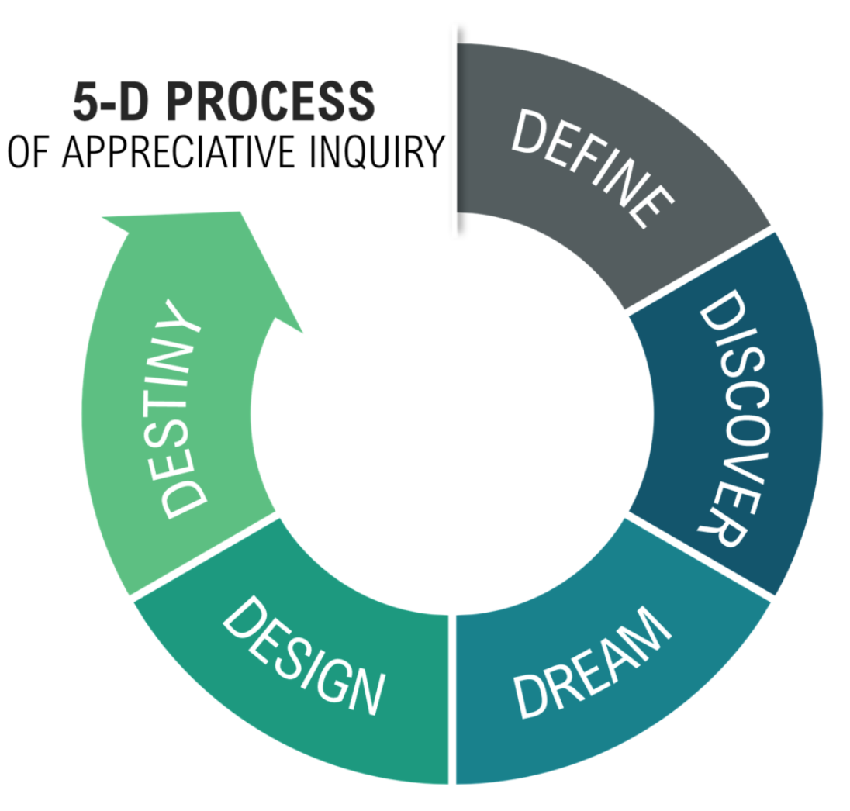
Appreciative Inquiry has been applied across sectors; from global corporations to municipal governments to federal agencies. The process has been found to generate participation, build trust, and produce strategies that communities feel ownership over. Volunteer Maine has selected this process to inform its State Service Strategy and understand the positive difference volunteering makes in communities, the role Volunteer Maine has played in those successes, and how bright the future of volunteering could be three years from now.

Image From The Center for Appreciative Inquiry.

